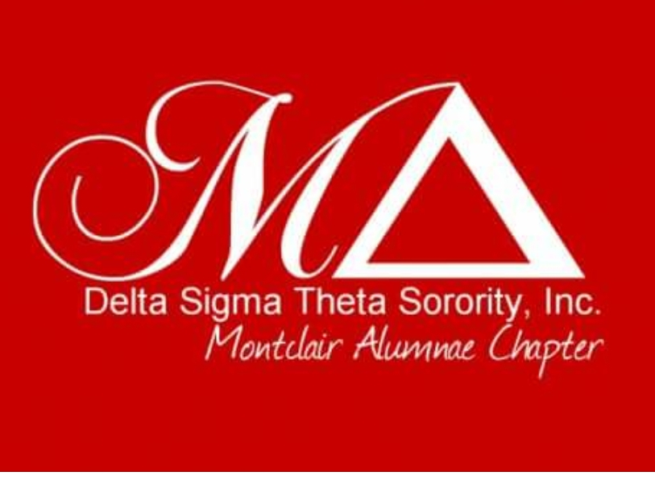
CHAPTER MEETING MINUTES
Date: October 23, 2020
Chapter President Paquita Mason called the Montclair Alumnae Chapter to order at 7:03pm. A motion to accept the agenda was properly seconded and passed. A motion to adopt the minutes of October Meeting was moved and properly seconded and passed with no correction via Zoom conference. A quorum was present for the transaction of business.

President’s Report – Paquita Mason
President Mason started her report by Congratulating all the committee chairs on a fantastic Committee Fair, which each Committee Chair gave a brief synopsis of their committee.

President Mason also informed all chapter member of the change that our regular Zoom meetings will now be done as a Zoom Webinar.

National – We are still following the guidelines from the state regarding how many can meet in person and also our National President who sent an email stating until further notice we are 100% Virtual. We can do food donations, school donations, etc in person following social distancing and protective gear on.
Regional- The report from the Regional Conference will posted in the sister portal before Chapter Meeting
State – We still are not at our 500 goal for State License Plates. There has been some rumbling about the $100.00 price and some said will wait until the price lowers to $50.00. The price will not drop if we do not get to 500 applications. Not that we are in competition with the D9, AKA has there plates and Zeta begun the process.
Local- I am happy to announce 3 appointments :Soror Deidra Rudd- Financial Secretary, Soror Francine King Cowan, Assistant Financial Secretary and Soror Jayda Yizar, Corresponding Secretary.

1st Vice President - Julie Brewer

Agenda
- Committee Fair
- Committee Directory
- Committee Communication Internal /External
- Upcoming Committee Events / Making Strides Donation /Breast Cancer Webinar

On October 9, 2020 Program Planning Meeting was scheduled with Chairs. It was successful and well attended. The following topics were covered:
- Committee Fair on 10/23/2020,
- Committee Logistics, Budget Adjustments
- Committee communication internal/ external
- Virtual platforms for committee meetings, events, meeting dates and time
- Chapter committee database and directory of chairs
- Program evaluation and public service record keeping
Budget Request / Adjustments __ yes X_No

Executive Board/ Chapter Action Requested __yes _X no

2nd Vice President – Solange Davis
Fall reclamation – will occur on either November 7th or November 14th. Asking all Sorors who know of any inactive Sorors to please send the contact information of the inactive soror to: mac2ndvp@montclairalumnae-dst.org or text me at 973-615-4996 so an invitation to our fall reclamation event can be extended. The committee’s reclamation goal is 10%.
In addition, the committee will continue to execute the Soror of the Month. We will also add a component called Soror Spotlight to highlight personal events/major accomplishments of a chapter member that take place outside of the chapter. On that note, the first soror who will be spotlighting Soror Kim Lewis-Collins for becoming the Director at Career Development at Fordham University/Gabelli School of Business. Please look out for additional details during the presentation about Soror Lewis-Collins achievements at this month’s chapter meeting.
We will continue this year with the Soror of the Month with the criteria remaining the same as last year. Sorors are encouraged to identify members who meet the criteria and submit their names as well as the documentation supporting the reason for the nomination. The committee will start reviewing submissions during our November meeting.
Financial Secretary – Soror Rudd
Soror Rudd wanted Sorors to know that all receipts forth coming will be issued by email.

*Please see report in full detail listed in Portal
Month Ended: September 30,2020
Chapter Meeting (10/23/2020)
 | Opening Balance (Receipts Only)
 | Year to Date August 31, 2020 |  | 1,445.00
 | September Activity
 | Local Dues |  | $ 1,600.00
 | National Dues |  | $ 200.00
 | Per Capita |  | $ 70.00
 | Reinstatement-National |  | $ 25.00
 | Social Action Virtual Prayer Service |  | $ 1,237.96
 | Scholarship-Donations |  | $ 31.00
 | Total Activity |  | $3,163.96
 | Year to Date Receipts Sept. 30,2020 |  | $4,608.96
 | Investment Income
 | Franklin Templeton |  | $ 5,635.10
 | Transfers between Accounts
 | Overpayment of Dues from Operating |  | $ -(210.00)
 | To Scholarship |  | $ 210.00

Treasurer – Karla Spivey
Soror Spivey welcomed her financial team: Soror Rudd, Soror King-Cowan and Soror Servere

*Please see report in full detail listed in Portal

PNC Bank Account - $62,610.78
Operating Account as of 9/30/20 ($55,122.28)
Scholarship Account as of 9/30/20 ($7,488.50)

Investment Account
Franklin Templeton as of 9/30/20 ($54,794.61)
Invesco as of 9/30/20 ($16,742.51)

Total All Accounts - $134,147.90

Committee Reports:

Special Projects – Soror Robin Johnson
Soror Johnson would like all Sorors to participate by sending gift cards for Thanksgiving of any amount to help families for Thanksgiving, these gift cards can
be sent to our P.O Box. Soror Johnson would like to receive them no later than November 13, 2020.

Founders Day Committee:
The Founders Day Committee would like Sorors to submit photos of themselves with our lovely Delta Dears. These photos can be emailed to:
macdst.foundersday2021@gmail.com

Physical & Mental Health – Soror Michele Johnson- Lewis
Soror Johnson-Lewis would still like to encourage Sorors to please donate to the American Breast Cancer Society by walking in Making Strides Newark for and raising money for this important cause. Any amount helps and no amount is too small.
Please click on this link to donate: http://main.acsevents.org/site/TR/?fr_id=97654&pg=team&team_id=2553189
Soror Johnson – Lewis is also asking Sorors to join the World Diabetes Day Webinar featuring Dr. Anjali Grover – Saturday, November 14, 2020 at 2:00 pm

Unfinished Business - None
New Business - None
Announcements - None

Adjournment
Meeting adjourned at 8:22pm

Soror LaTanya Carter, Recording Secretary

